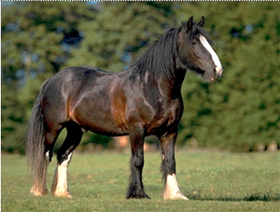
Magbred Heavy Warhorse(Shadowmist)
- Rescued from goblins at Thistletop.
- Appearing to be a fine specimen of their kind, these have been magically bred animals that are plainly better than their mundane kin. Magebred animals usually have higher ability scores and are easier to train than mundane animals.
Hit Dice: 4d8+16(35hp)
Initiative: +1
Speed: 60 ft. (12 squares)
Armor Class: 16 [T10 FF15] (-1 size, +1 Dex, +6 natural)
Base Attack/Grapple: +3/+13
Attack: 2 hooves +8 (1d8+6), 1 bite +3 (1d4+3)
Space/Reach: 10 ft./5 ft.
Special Attacks: —
Special Qualities: Low-light vision, scent
Saves: Fort +7, Ref +5, Will +2
Abilities: Str 22, Dex 15, Con 19, Int 2, Wis 13, Cha 6
Skills: Listen +5, Spot +4
Feats: Endurance, Run, Improved Natural Attack(Hoof)
Carrying Capacity: Light load up to 519, medium load 520-1038, Heavy load 1039-1560

